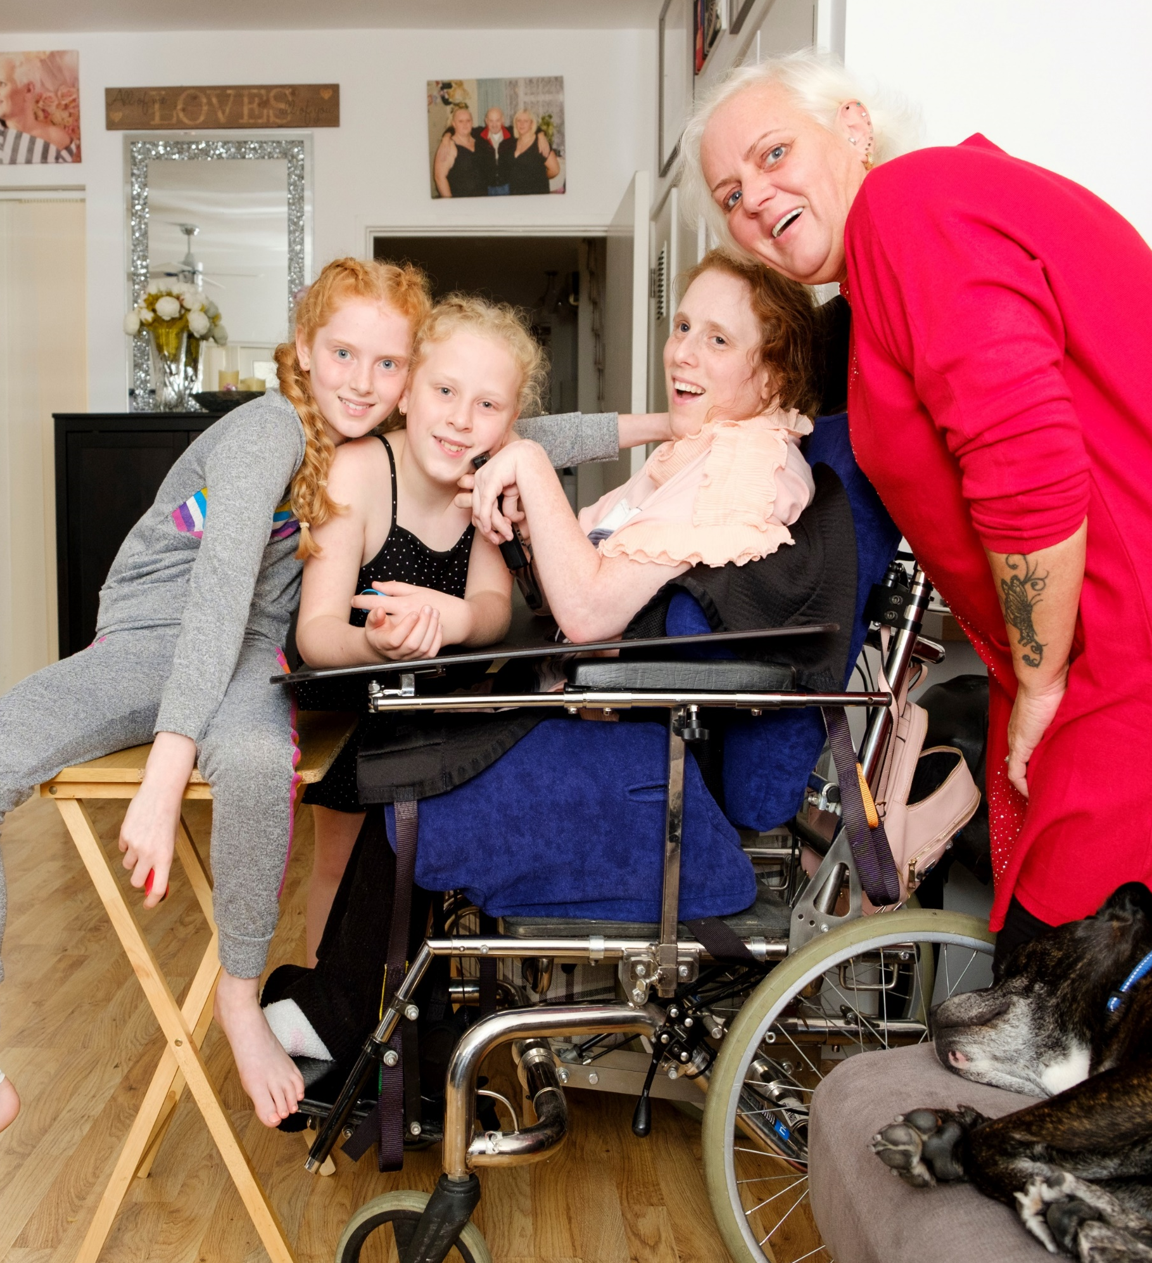


Candidate Pack
Team Lead

Welcome

Thank you for your interest in working for Carers First as our next Team lead (Haringey and Waltham Forest).

This is a permanent role

You will be joining a charity that has a new ambitious three-year strategy to grow our reach, support and impact for carers, working in collaboration and partnership with a range of statutory, voluntary and commercial organisations.

To be successful in this role you will need:

- Experience of leading or supervising a team, ideally in health, social care or voluntary sector settings
- Strong understanding of carers’ needs, and confidence delivering assessments and personalised support
- Excellent communication skills and the ability to build relationships with carers, colleagues and partners.
- Confidence using digital tools including case management systems and Microsoft Office
- A passion for working in a value-led organisation and making a difference in people's lives

If you have the passion and drive to make a difference and you have the experience and skills we are looking for, we are keen to meet you - and welcome you to our dedicated and talented team.

Warmest wishes

Alison Taylor
Chief Executive



About us
We understand that life as a carer can be challenging. Getting the support and help you need shouldn’t be.
Any of our lives could be turned upside down due to the ill-health, frailty or disability of a family member or friend. In fact, two in three of us can expect to become a carer in our lifetime.
There are currently 5.7 million unpaid carers in the UK, however carer charities estimate that number could be as high as 10.6 million. Their huge contribution saves our economy £184 billion each year - the cost of a second NHS. Each carer’s needs and situation are unique, but many face similar challenges. They can struggle to balance employment, finances, or their own wellbeing and time for themselves with their caring role. They may not be aware of the help and support available to them - and that is why we are here.
Carers First works directly with, and for carers, providing personalised information and tailored support in the way that suits them: online, on the phone, or face to face in their local community. With the help of our supporters and volunteers, we can continue to be there for carers, helping them find balance, and to live their lives to the fullest - today, and for years to come.

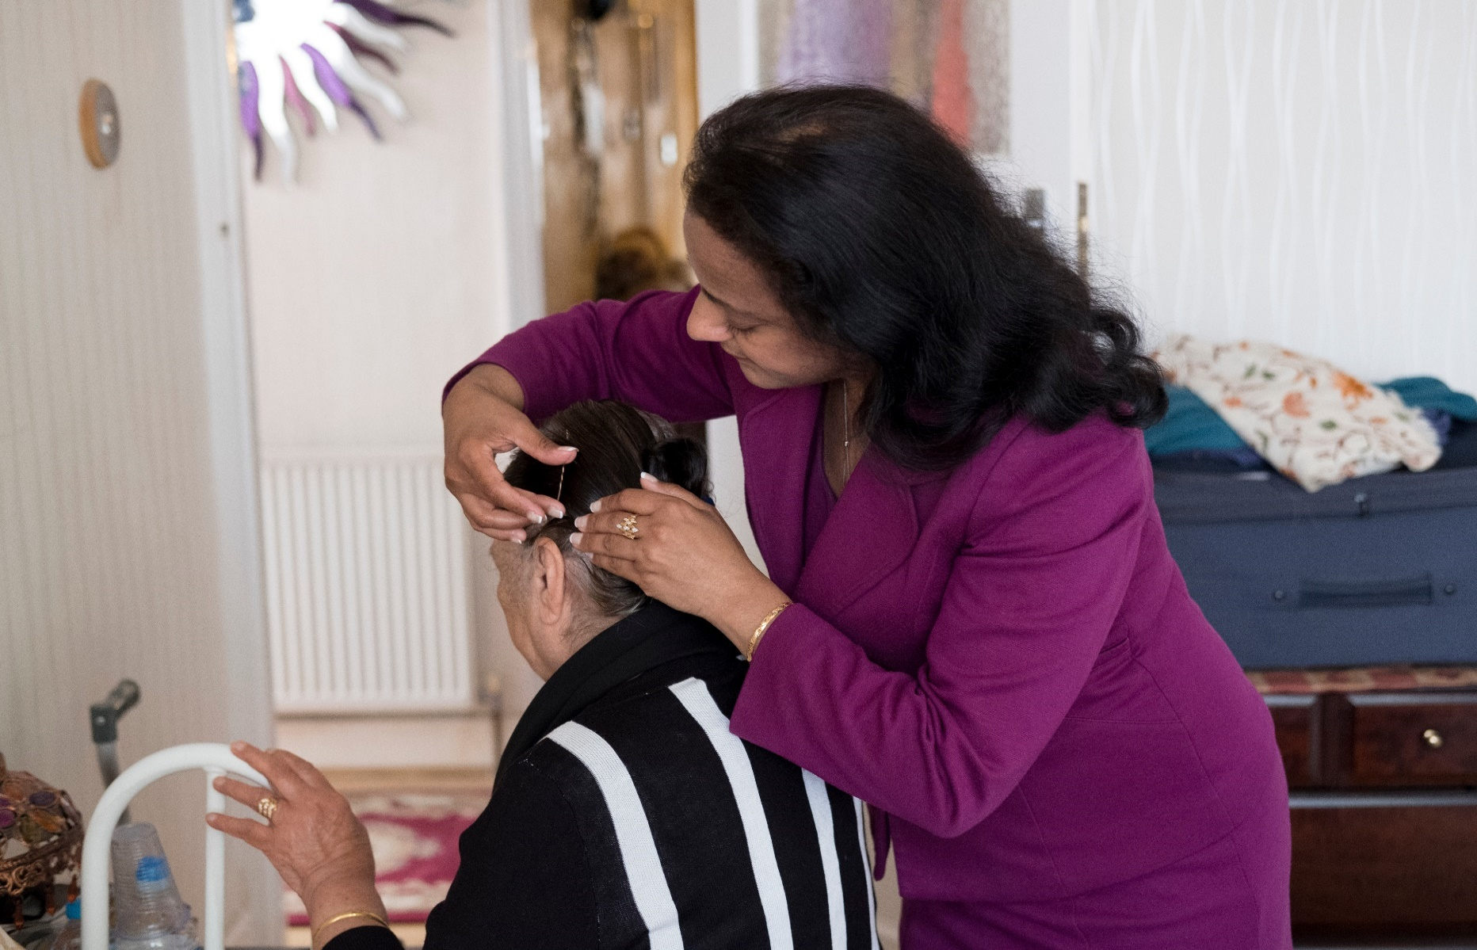
Our values
We are:

Positive
We are dedicated to working with carers to make a positive, material difference in their lives. We celebrate diversity and work in an inclusive, positive and supportive way, actively listening and valuing everyone’s contribution.

Collaborative
We recognise the importance and strength of working in collaboration with local and national organisations to deliver improved support to carers. We also know the importance of collaborating with our Carers First colleagues, sharing knowledge and learning, being curious, respecting differences and working with integrity and transparency.

Ambitious
We are ambitious and tenacious in our determination to support more carers in better ways. We will innovate and develop our programmes of support, so more carers are able to obtain the support they need, at the time they need it, to achieve a balance in their lives and enable them to live their lives to the fullest.

Diversity and Inclusion

We are proud to be a diverse and inclusive workplace.
Carers First is committed to promoting equal opportunities in employment. Employees and any job applicants will receive equal treatment regardless of age, disability, gender reassignment, marital or civil partner status, pregnancy or maternity, race, colour, nationality, ethnic or national origin, religion or belief, sex or sexual orientation (Protected Characteristics).

Carers First has an absolute commitment to equality and diversity which is about:
- Recognising and valuing difference.
- Recognising and seeking to redress inequality and disadvantage.

Our commitment is firmly founded on our belief that:
- To offer services that are personal, committed and creative we need a diverse staff team who can respond to our carers as individuals.
- To attract, keep and motivate the most talented staff, we need to:
  - Reach out to all sections of the community.
  - Provide a working environment in which everyone feels valued, respected and able to contribute.

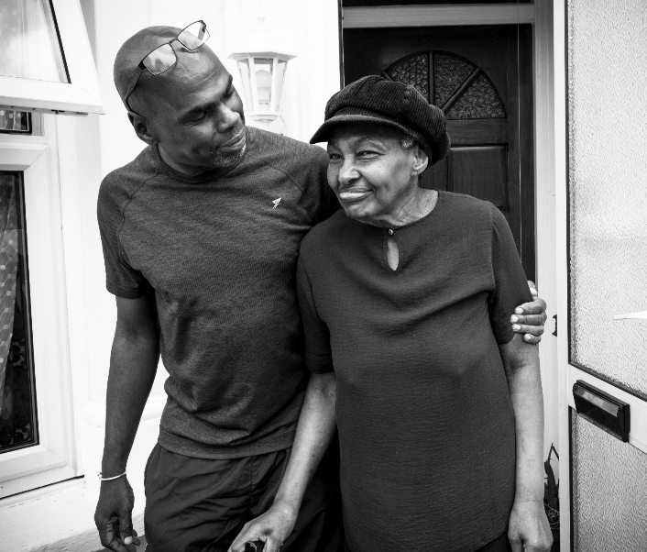
The charity recognises that true diversity in service delivery provision and within the staff group also involves a willingness to act, where necessary, at combating the effects of existing barriers to fair and equal treatment.

Our strategy 2024-2027

Our three-year strategy will enable us to grow our work to reach and support significantly more carers, deliver innovative programmes of support in coproduction with carers and forge new collaborations to scale our reach, support and impact for carers.
Strategic Objectives
Over the next three years Carers First will:

- Reach and engage more carers early in their caring role
- Develop new innovative models of collaboration, delivery and programmes with the potential to scale our reach and impact
- Achieve the highest quality of support possible, so we can maximise the difference made to carers lives
- Champion talent and diversity
- Grow and diversify our income to enable us to achieve more for carers.
Our support and services are designed with carers, ensuring the support we offer is inclusive and accessible to all carers in different communities.​
By joining Carers First, you will play a vital part in helping us achieve this. You can help us achieve something amazing.

How we work

We support young carers, young adult carers and adult carers throughout England with our comprehensive online offer including information, advice and guidance, tools, resources and training, as well as through our vibrant online peer support communities.

We also deliver locally commissioned services in Lincolnshire, Essex, Medway, Southend and in four London Boroughs.

We offer a range of support options for carers to access in ways that work best for them:

- Face-to-Face Support: Available both one-to-one and in group settings, providing personalised and community-based assistance.
- Online Support: Accessible resources and virtual sessions to ensure carers can connect with us anytime, anywhere.
- Dedicated Helpline: A trusted source of advice, guidance, and a listening ear for carers navigating their journey.
- Extensive Online Resources: Comprehensive and easy-to-use tools, guides, and information to empower carers with knowledge and confidence.
- Collaborative Partnerships: Working with organisations and communities to provide a seamless network of support tailored to carers’ needs.
Our impact and reach
Carers First Impact Framework sets out our Theory of Change and the measures and tools we use to understand the outputs, outcomes and impact of the support we provide.

Last year, we reached over 330,000 people to provide information about caring and 51,000 carers are registered with us to receive information and support.

In numbers

- 96% of carers felt more resilient in their caring role after our support.
- 95% of carers felt listened to and that their own needs were taken into account through our interventions.
- 93% of carers felt more confident and informed in their caring role after our support.


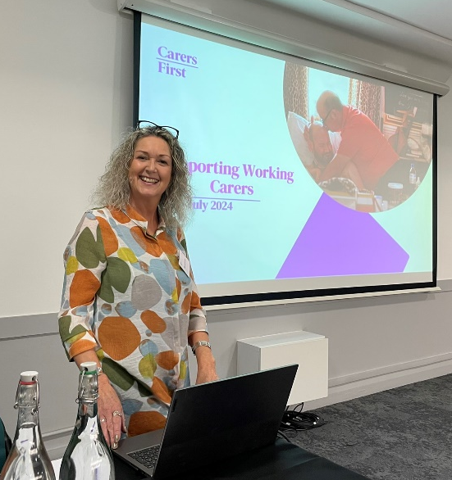


Join our team

When you join Carers First, you join a vibrant, inclusive, and supportive team who all have a shared interest in supporting unpaid carers to continue living their lives to the fullest, across the country.

In a community dedicated to caring, we believe that our employees and volunteers really do make a difference, therefore, we emphasise the importance of learning and development, as well as actively encouraging them to develop their skills with our fantastic learning and development programme. This means that all of our team become the best that they can be, whilst helping others do the same.

The role

Job Title: Team Lead
Salary : £28,050 per annum
Contract: Permanent
Hours: 37 hours per week.
Location: Haringey and Waltham Forest – working flexibly from home and in the community.

Job Description

Job title: Team Lead (Haringey and Waltham Forest)

Reports to: Service Manager (Haringey and Waltham Forest)

Purpose of the role:. To lead and deliver a high quality, innovative and inclusive service for unpaid carers across Haringey and Waltham Forest. The Team Lead will support the development of a strengths-based, person-centred that improves outcomes for carers and strengthens community partnerships. This is a hybrid role combining leadership responsibilities with direct

service delivery and casework, including managing a small number of complex cases.

Job Overview

The team lead will

- Provide visible, day-to-day leadership to a team of Carer Support Advisers, supporting delivery of the carers offer in Haringey and Waltham Forest.
- Actively contribute to service innovation and development, identifying gaps and working with carers and colleagues to co-produce new approaches.
- Build strong, positive relationships with local stakeholders, championing the needs of carers and ensuring a coordinated response across sectors.
- Deliver frontline support directly to carers, including carrying a small, complex caseload and conducting statutory and strengths-based assessments.
- Uphold the standards of Carers First through quality assurance, monitoring, and safeguarding practice.

Responsibilities and Duties

- Team Leadership and Service Delivery

- Lead and support the local delivery team, fostering collaboration, learning and high performance
- Guide staff in delivering quality carer assessments and co-produced action plans using statutory and Carers Star frameworks
- Champion inclusive, culturally aware practices tailored to the diverse needs of carers
- Identify service gaps and opportunities for innovation, improvement or added value
- Deliver direct support to carers, managing a caseload of complex cases and modelling best practice
- Carry out statutory assessments and personalised support planning in line with local authority requirements
- Provide carers with tailored advice, information, and emotional support
- Quality, Monitoring and Safeguarding

- Ensure carer interactions are accurately recorded in line with Carers First policy and commissioner expectations
- Monitor team performance against KPIs, providing coaching and feedback to maintain quality
- Undertake regular case audits and contribute to continuous improvement through quality assurance processes
- Promote safeguarding best practice, ensuring team members are confident and compliant in their responsibilities

- Stakeholder Engagement and Partnership Working

- Build and maintain partnerships with health, education, voluntary and community
organisations in Haringey and Waltham Forest
- Represent Carers First at forums and local partnership meetings
- Drive collaboration to expand reach and impact for carers
- Support stakeholder engagement and champion carers’ voices in local planning
- Promote services locally via communications channels, in collaboration with the Communications Team
- Remain flexible to support wider charity operations as required; this job description may be reviewed periodically

- Organisational Responsibilities

- Ensure compliance with Carers First policies and procedures, including safeguarding, health and safety, GDPR and equality, diversity and inclusion
- Support the Service Manager with reporting, budget monitoring and data submission
- Contribute to a positive working environment, promoting Carers First values and vision
- Be flexible in undertaking additional duties, as required, to support the effective delivery of the service

These are the normal duties that are required for this position. However, it is necessary for all employees to be flexible, and they may be required, from time to time, to perform other duties as may be required for the efficient running of the charity. This Job Description is non-contractual, it will be subject to reviews and may change.

The postholder will take responsibility to integrate safeguarding into all aspects of their work, complying with organisational policies and frameworks.

The postholder will be expected to ensure that their work complies with contractual terms and conditions, the charity’s policies and procedures and key legislation, including the General Data Protection Regulation (GDPR) and charity law.
Person Specification

Education and Qualifications

- NVQ Level 2 or equivalent relevant experience

Skills and Experience

Leadership and Management

- Experience of managing or supervising a geographically dispersed team
- Able to motivate, develop and support individuals and promote a team culture
- Experience of driving service improvements through learning, feedback and reflective practice

Working with Carers

- Experience of delivering support to unpaid carers or similar support-based roles
- Understanding of carer-related issues, including the statutory rights of carers
- Skilled in delivering or overseeing support planning and solution-focused interventions
- Confident working with safeguarding concerns and escalating appropriately
- Experience in direct service delivery, including casework, and personalised planning

Partnerships and Communication

- Experience of working in partnership with statutory and voluntary sector services
- Strong interpersonal skills with the ability to develop trusted and productive relationships
- Confident public speaker and advocate for carer issues

IT and Systems

- Proficient in using Microsoft Office and digital platforms
- Experience of working with databases to manage service records and caseloads

Personal Qualities

- Ability to demonstrate understanding of and an ambitious commitment to the goals and values of the charity.
- Demonstrate a positive level of professional credibility, integrity, and emotional resilience.
- Self-motivated, collaborative, and able to work flexibly, whilst maintaining good work/life balance.

Rewarding our employees
We provide a reward package for our employees upon joining Carers First.
Our reward package includes:
- 26 days Annual Leave which increases with continuous service + Bank Holidays.
- 1 days Birthday Leave
- Benenden Private Healthcare Membership (following successful probationary period)
- Pension
- Death in Service Benefit
- Employee Assistance Programme
- Carer Passports
- High Street Discount Platform
- Flexible Working Options

How to apply
To apply for a role with Carers First, please complete in full our online application form via our website: https://www.carersfirst.org.uk/about-us/working-for-us/

Appointments are subject to Carers First receiving an appropriate disclosure from the Disclosure and Barring Service that we consider acceptable.

We encourage and welcome applications regardless of gender, ethnicity, religion, disability, sexual orientation or age.

If you would like to discuss this role confidentially, please contact us at, recruitment@carersfirst.org.uk, and we will be happy to organise one of the Team to contact you.

Interview process

All successfully shortlisted candidates will be invited to two meetings:

Stage 1: An informal online meeting to discuss their application.

Stage 2: A face-to-face meeting with an interview panel. You will be required to do a presentation, and details will be provided in advance.

Tips on completing your application
- Read the Job Description and Person Specification carefully.
- Be sure to include your employment history, details of relevant duties to the role you are applying for and any transferable skills you may have.
- Include any other work or volunteering experience you have which you feel is relevant.
- Read the Skills and Experience required for the role in the Person Specification and demonstrate clearly in your application evidence of how you meet each of these.

Office:
Michael Gill Building, Tolgate Lane, Strood, Kent ME2 4TG




